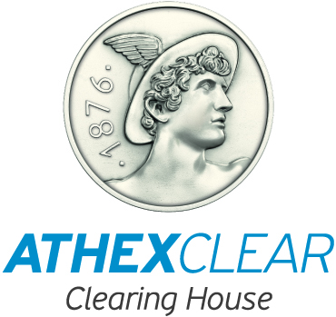
ATHEXClear Form [17-127]
AGREEMENT FOR THE PROVISION OF THE SFTR SERVICE

Between the company: |  | and the company (legal name and registered office):
Athens Exchange Clearing House S.A.
110 Athens Avenue
Athens 104 42
hereinafter referred to as "ATHEXClear" |  | hereinafter referred to as the "Clearing Member"

ATHEXClear and the Clearing Member hereby enter into this agreement for the provision of the SFTR service on __ / __ / _____. The agreement also includes the General Terms and Annexes, which form an integral part hereof (together hereinafter referred to as the “Agreement”):

GENERAL TERMS
ANNEX A: "Technical Specifications of the SFTR Service”
ANNEX B: "SFTR Service Fees”

The Clearing Member has understood and accepts the aforementioned General Terms and Annexes, which are posted on the website http://www.athexgroup.gr

The Clearing Member assigns to ATHEXClear and ATHEXClear accepts the reporting of securities financing transactions (SFTs), in accordance with article 4 of Regulation (EU) 2015/2365 in the following cases:

Reporting of any SFT concluded by a Clearing Member in the Securities Lending Mechanism of ATHEX with ATHEXClear and with the Clearing Member’s clients, for which the reporting obligation lies with the Clearing Member.
Reporting of any SFT concluded by the Clearing Member’s Authorising Clients with the Clearing Member in the Securities Lending Mechanism of ATHEX, for which the reporting obligation lies with the Authorising Clients.
Reporting of any SFT concluded over-the-counter or in regulated markets other than ATHEX by the Clearing Member or by its Authorising Clients, for which the reporting obligation lies with the Clearing Member or its Authorising Clients respectively.

The Clearing Member declares as contact person for the SFTR Service:
Full name: ______________________________ email: ____________________ tel: ____________________
THE PARTIES
FOR THE CLEARING MEMBER  [Legal Representative’s Full Name - Signature - Company Seal] |  | FOR ATHEXCLEAR

